**Table of Contents:**

System Objectives ---------------------------------------------------------------------1

**Design**…………………………………………………………………………1

Data Flow Diagram……………………………………………………….2

Use Case Diagram…………………………………………………..........3

Class Diagram(UML)……………………………................................................4

ER Diagram……………………………………………………………….5

Activity Diagram………………………………………………………..6

Sequence Diagram………………………………………………………7

**System Objectives:**

The main objective of this software project is to build an Online banking system for bank customers. By using Online Banking services customers and prospective customers can save time and get easy access to the account.

**DESIGN:**

**Data Flow Diagram:**

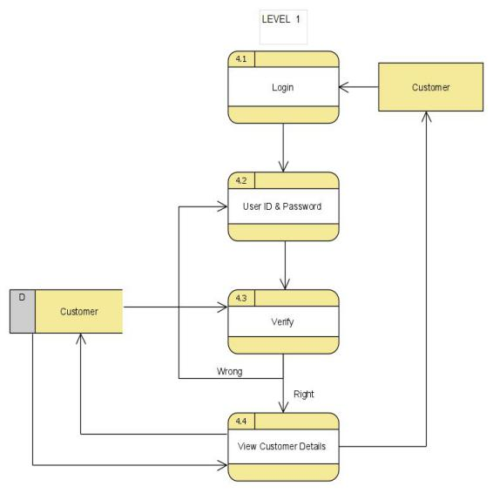

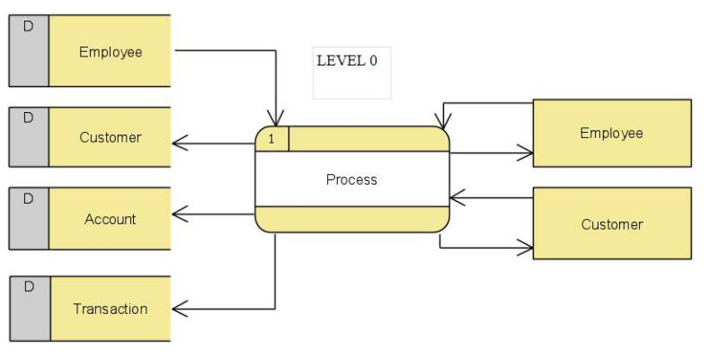

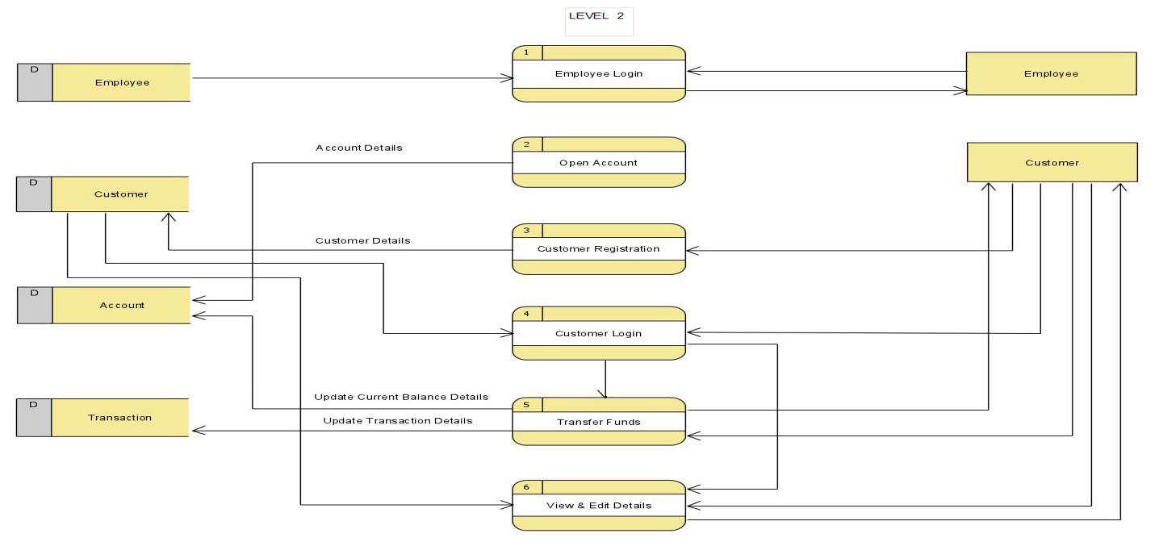

**Use case Diagram:**

Manage/ Add Customer Information

**Employee**

Open account

Login

View Details

**Customer**

Initiate Fund Transfer

Update transaction

View Transaction

View Contact Detail Details

Edit Contact Details

Logout

**Class Diagram:**

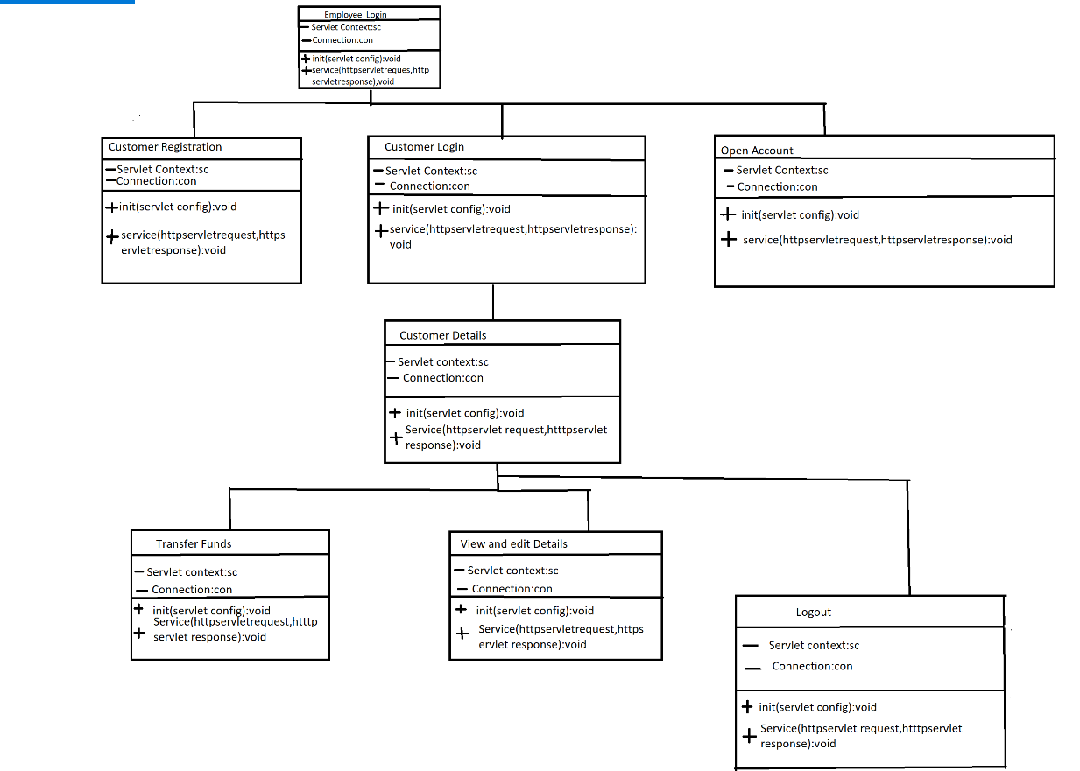

**ER Diagram**

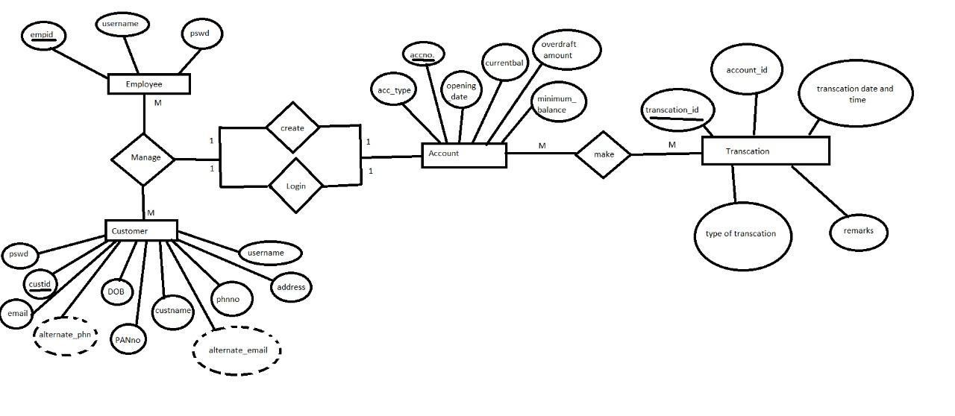

**Activity Diagram:**

Customer

View Details

Correct/ Incorrect

User Id and Password

Login

Wrong Credentials Right Credentials

Operations

Fund Transfer

Update Transactions

View Transactions

Change Credentials

Logout

**Sequence Diagram:**

The Sequence diagram shows the interaction between employee, customers and customers account in the order.

Employee Customer Account

Add Customer

View Details

Fund Transfer

Update Transactions

View Transactions

Update Credentials

Logout